
Make Shopping a Party!

Final Report
CS147 Autumn 2025
Adulting Made Easier
Luke M. | Isaac P. | Anthony R.

The ShopCrawl Team

 | Luke M.  Frontend / UI Developer
Isaac P.  Backend / Web Developer | 
 | Anthony R.  API Developer / Integrator

The Problem
Chore shopping feels boring and monotonous, so people aren’t excited to do it. At the same time, it’s hard to meet new people and time is valuable, making everyday shopping feel like a lonely, inefficient task.

The Solution
ShopCrawl: an app that makes shopping fun by turning it into social, in-person experiences instead of a solo chore. It does this through community events, customizable “crawls,” and social features that help people explore stores together and meet shopping buddies.

Needfinding
Interviews
Initially, we identified chore shopping as a primary focus area for our project. As our team approaches graduation, we collectively recognized that shopping—whether for groceries, household necessities, or items for our future homes—can often be a confusing and daunting task. To better understand this issue, we engaged both novice and experienced shoppers to explore how they developed their shopping habits, the anxieties they still face, and the tips and tricks they have acquired from others or through their own experiences. Our objective in this need-finding phase was to uncover the common challenges faced by shoppers and to gather unique insights that would inform our decision-making.
We ventured into our local community, visiting a diverse array of stores to intercept and interview shoppers as they went about their shopping. In an effort to ensure diversity in age, gender, and economic background, we targeted both budget-friendly retailers, such as Target and Walmart, as well as higher-end establishments like Whole Foods and Sur La Table. Shoppers were approached with requests for interviews during their shopping trips, and we were pleased to find that many agreed without expecting compensation.
In our two-person teams, one member acted as the facilitator, conducting the interviews, while the other recorded the interviewee's words, actions, and emotions. In total, we conducted interviews with five individuals:

Candace
A teacher and deal-hunter using 10+ shopping apps, interviewed at Target while shopping for clearance items. Her main pain points:
- She felt conflicted shopping at big-name stores based on their actions and morals
- Wants to support local businesses but can’t afford to
- Likes to shop in person, but online retail is too convenient

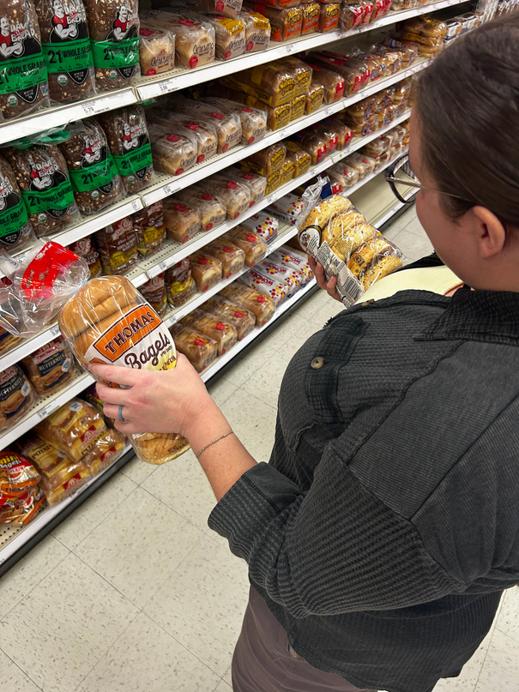
Figure 1: Candace deciding between two different brands of bread
Ferb
Ferb is a frequent shopper whom we met at Walmart who buys groceries for his whole family, walking to the store with his own cart and a WhatsApp list from his mother. His main pain points:
- He loves to shop in person, but it’s difficult for him to physically get there
- He feels many big-name stores lack a human touch to the shopping experience

Interviews pt. 2
After our interviews with Ferb and Candace, our team opted to refine our focus from deal hunting, shopping hacks, and organization to enhancing the in-person shopping experience, making it more enjoyable and authentic. To further our exploration, we interviewed a recent college graduate as well as a pair of friends engaged in chore-related shopping.
Monica
A recent graduate who recently moved to New York City and has difficulty navigating chore shopping in a new place on her tight schedule. Her main pain points:
- She struggles to find deals in stores
- Has a hard time finding time to shop during the day
- Doesn’t see the compounding value of saving money
Ash and Gary
We met Ash and Gary at Micro Center. They are recent graduates from San Jose State University. Their main pain points:
- They liked to shop with friends, but felt like it was inconvenient to do so
- Ash lacked confidence in his ability to select a good product to buy when it comes to electronics
- Gary wants to spend more time with his friends, but feels like work and shopping get in the way

Synthesis
Utilizing FigmaJam, we developed two distinct empathy maps to effectively organize and analyze the verbal, physical, and emotional insights gathered from our interviews. We created empathy maps from our interviews with Candace, Monica, Ferb, and Ash and Gary.
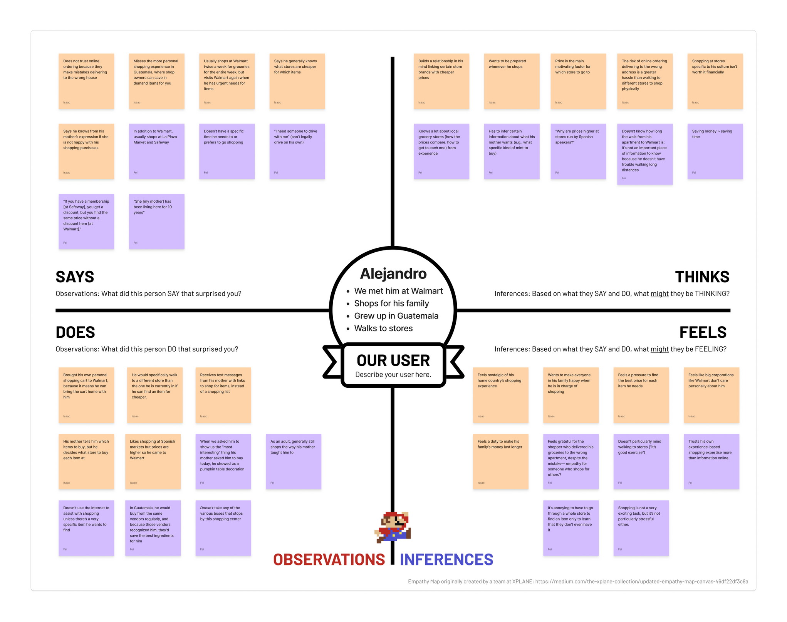 | 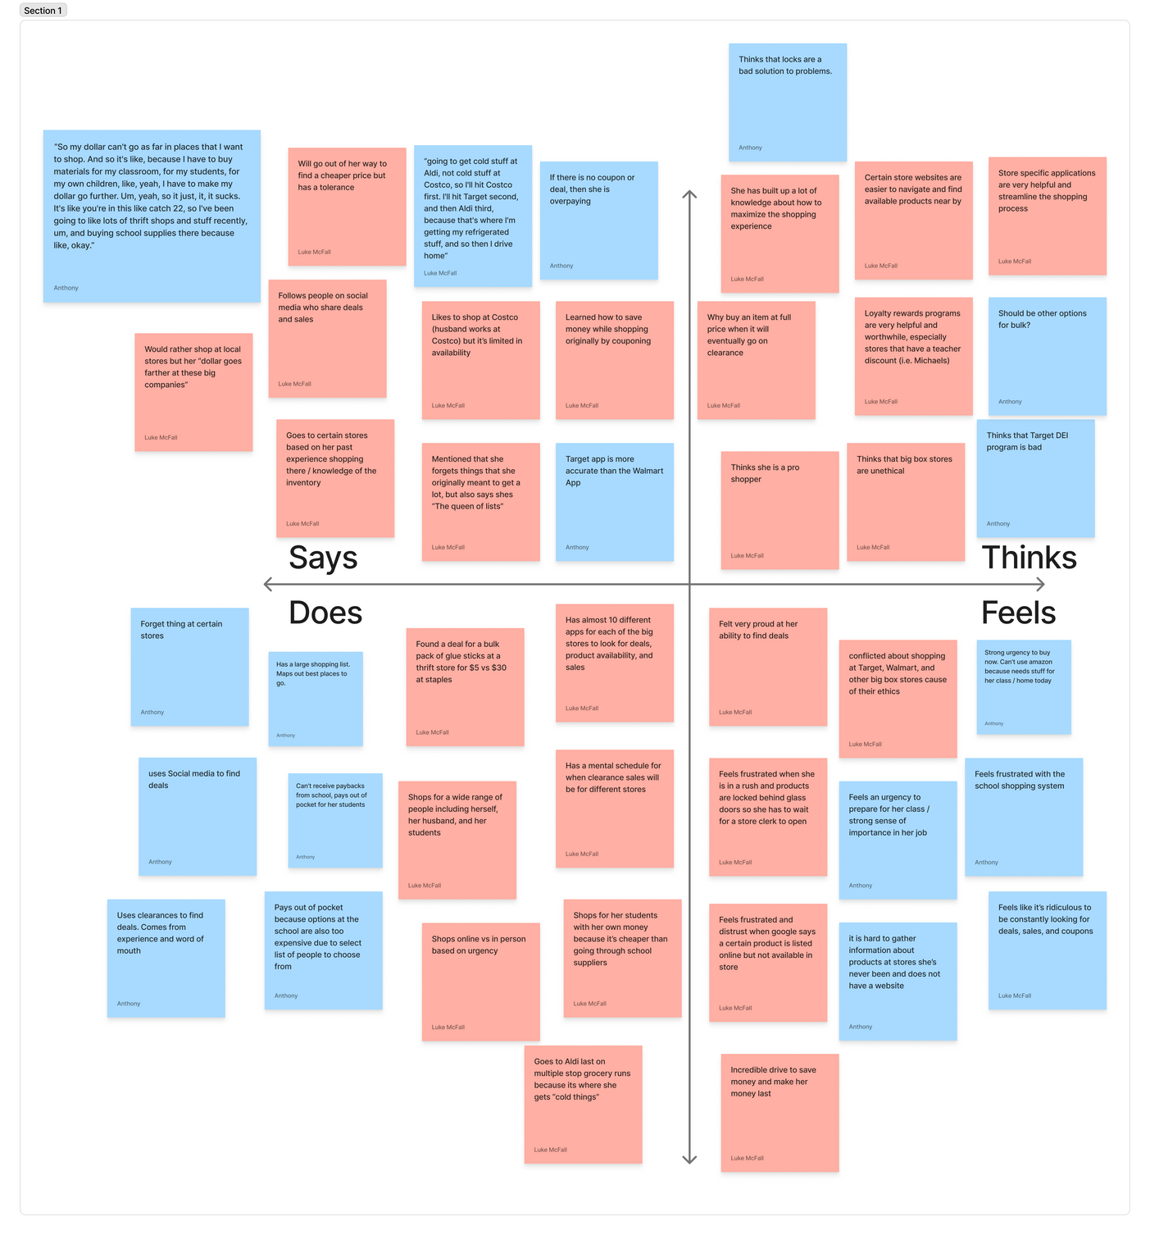
Figure 2: Empathy maps for Candace and Ferb
From the empathy maps, we discovered that individuals are significantly more motivated by the prospect of saving time than by saving money. Additionally, there is a pronounced social aspect to chore shopping that greatly enhances the overall enjoyment of the experience. Finally, many shoppers express a preference for authentic, in-person interactions, often expressing disdain for online and big-brand retail, although they may still resort to these options when prices are favorable.

POVs:
To continue exploring our new findings, we generated POV statements to better understand the tension and emotions behind the problems our interviewees were facing. We wrote POV’s for Ferb, Monica, and Ash and Gary.
Ferb POV
- We met Ferb, a shopper who walks to stores to do his weekly shopping because he doesn’t own a car
- We were surprised to notice his preference for shopping in-store despite the extra effort, choosing it over the convenience of shopping online
- We wonder if this means Ferb values the control of being able to see, touch, and decide on the spot while shopping, more than clicking through options on a website
- It would be game-changing if there were a shopping experience that enhances Ferb’s control over his shopping experience, no matter where he shops
HMW Statements from Ferb’s POV
- HMW be able to bring the physical shopping experience to the home?
- HMW share one’s personal expertise with less experienced shoppers?
- HMW make physically going to the store more convenient than online shopping?
- HMW leverage online deal-hunting skills in the physical stores?
Ash and Gary
We met Ash and Gary, recent San Jose State grads who often shop together as part of big groups.
We were surprised to notice that they still brought each other along even for a simple, single purchase.
We wonder if this means they rely on their group members’ individual areas of expertise to relieve the anxiety of making the wrong choice.
It would be game-changing if Ash and Gary could gain the confidence to make wise shopping decisions, even when separate.
HMW Statements from Ash and Gary’s POV
- HMW remove the need to be an expert on the product you are shopping for?
- HMW make chore shopping a social experience like shopping for fun?
- HMW make it impossible to make unwise financial decisions while shopping?
- HMW make strangers a trustworthy source of expertise?
Monica
We met Monica, a recent college graduate who moved to New York City, who is still figuring out the average prices and cost of living around her new home.
We were surprised to notice that she enjoys executing deals on things she wants to buy, but doesn’t care to execute deals on everyday essentials.
We wonder if this means Monica is bored and exhausted from the process of using deals, but excitement for an item overcomes the hassle.
It would be game changing if Monica could feel this enjoyment for all her shopping needs.
HMW Statements from Monica’s POV
- HMW make the deal hunting more exciting for boring grocery and chore shopping?
- HMW show how much someone is saving money over many small deals?
- HMW pass knowledge of shopping tips from pro shoppers to new shoppers?
- HMW encourage exploration of different stores to find cheaper items or better deals?
Solutions
After extensive brainstorming, we developed over 30 HMW statements. To refine our focus and select three HMW statements for which we would generate solutions, we employed a heatmap-style voting method to gauge the group's enthusiasm. Following the voting process, we identified the three HMW statements that garnered the most interest:
- How might we transform chore shopping into a social experience akin to enjoyable shopping?
- How might we eliminate the necessity of being an expert on the products one is purchasing?
- How might we make the process of deal hunting more exciting for mundane grocery and chore shopping?
With these three focal points established, we engaged in 10-minute rounds of independent brainstorming to generate solutions for each statement. Subsequently, we reviewed and grouped similar ideas, utilizing heatmap-style voting, in which each participant cast three votes to identify the most favored solutions for each HMW. After completing the voting for each statement, we arrived at our top three solutions.
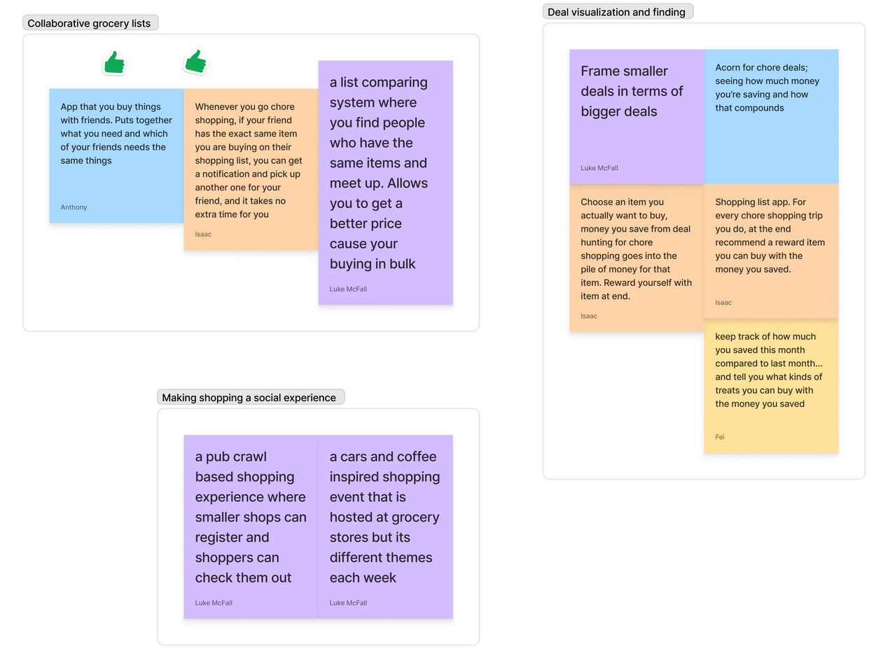
Figure 3: A FigmaJam board showing the final voting process for our top 3 solutions.
Top 3 Solutions:
- Sync shopping lists with friends to match shared items, letting you buy together for convenience, bulk savings, and chore-sharing.
- A themed, community-driven shopping experience where local shops join pop-up events, like a pub crawl or cars-and-coffee, inviting shoppers to explore new stores each week.
- A shore shopping app that tracks your savings from deals, shows how they add up over time, and rewards you by linking your savings to treats or big-ticket items you actually want
To evaluate these solutions, we meticulously developed three experience prototypes to verify the validity of the key underlying assumptions upon which the solutions were founded.

Experience Prototypes
Our three solutions operated under a set of solutions that we needed to test in order to know if the solution was viable. We designed 3 different prototypes with the express goal of understanding if a solution would work and if it would produce the desired result.

Experience Prototype: Collaborative Lists
Solution: Sync shopping lists with friends to match shared items, letting you buy together for convenience, bulk savings, and chore-sharing.
Critical Assumption: if someone is asked to buy additional items at a store they are already at (provided that they are not paying for these additional items), this will not make their shopping experience less enjoyable.
We developed our test to simulate a scenario in which participants were tasked with locating and “purchasing” additional items while searching for their own. Initially, we instructed the participant to locate red scissors within a specified area and to notify the team member overseeing the prototype upon their discovery. Once the scissors were found, our team member prompted the participant to identify two additional hidden objects to “purchase.” One item, masking tape, was situated near the red scissors and was easy to locate, while the other item, a pen, was more concealed.
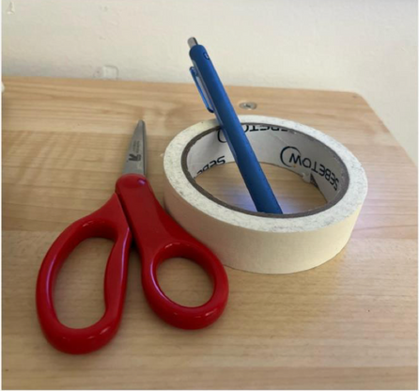 | Figure 4: The objects that our participant was tasked to find

Once the participant located all three objects, we conducted a brief interview to evaluate the aspects that were successful and those that were not. Below are our findings:
What worked:  - Participants used game-like RPG language, such as "side quest" and "inventory full," when asked to grab additional items.  - Felt like it was a fun task | What didn’t:  - Participants did not initially understand why they had to retrieve the additional items. "I'm trying to figure out the premise behind this quest  - Began to feel frustrated at the difficulty of finding the pen
From this prototype, we discovered that individuals are generally willing to go out of their way to assist others in locating an item. Although the participant expressed some frustration during the search for the pen, it was directed towards their own performance rather than the task itself. This experience prototype demonstrated that exerting additional effort does not hinder the overall shopping experience.

Experience Prototype: Social Shopping
Solution: A themed, community-driven shopping experience where local shops join pop-up events, like a pub crawl or cars-and-coffee, inviting shoppers to explore new stores each week.
Critical Assumption: Making shopping a spontaneous, meet and greet experience will improve the enjoyment of chore shopping.
While it is commonly assumed that individuals enjoy shopping with friends, we sought to investigate whether this holds true for those meeting for the first time. Our test was designed around the premise of pairing two individuals who had not previously met at a shopping location. Although our solution referenced local shops, we chose not to emphasize this aspect, as our primary objective was to maximize the likelihood of purchases. We selected Target as our prototype location due to its extensive selection of items.
To implement the prototype, we “invited” each participant to a “chore shopping adventure,” providing only the location and time without further details. Upon arrival at the store, a member of our team facilitated the introduction, encouraging the participants to engage in conversation while shopping together.
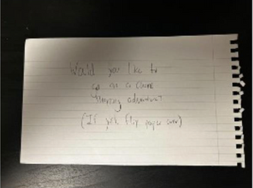 | 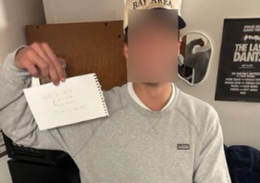 | 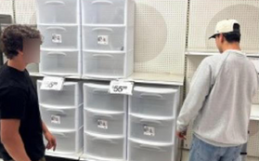
Figure 5: Left: the invitation given to both participants. Middle: participant 1 receiving the invitation. Right: participant 1 advising participant 2 on which container to buy for his dorm room.
What worked:  - Participants were both able to easily talk and converse through the medium of shopping  - Even though participant 1 didn’t end up buying anything at the store, they still enjoyed the experience  - Participant 2 consulted participant 1 on numerous items before purchasing one | What didn’t:  - At first, they felt uncomfortable while talking outside the store.  - Participant 1 expressed disappointment that Target was chosen because he was there earlier in the week
Overall, this prototype proved to be a significant success, validating our initial assumption. Both participants expressed delight and enthusiasm at the prospect of engaging in the experience again. The results demonstrated that utilizing shopping as a medium for meeting new people significantly enhanced their enjoyment during the chore of shopping.
Experience Prototype: Small Savings Made Clear
Solution: A chore shopping app that tracks your savings from deals, shows how they add up over time, and rewards you by linking your savings to treats or big-ticket items you actually want.
Critical Assumption: Showing small chore savings as progress toward a self-chosen big reward makes deal-hunting feel fun and increases deals used.
This assumption is critical because if connecting small savings to a larger personal reward does not make deal-hunting enjoyable, then the pursuit of minor chore savings becomes a tedious task. Moreover, if the use of deals is not increased, the rewards will fail to accumulate significantly over time to enable the purchase of a larger desired item.
To explore this, we set up a simulated two-week grocery shopping experience. Participants were provided with an example grocery list containing a mix of regular-priced and discounted items. A team member instructed each participant to create an initial grocery list based on their typical habits and to note the total cost. Participants were then encouraged to select an aspirational "reward purchase," with the understanding that "every dollar saved now goes toward this." Subsequently, participants crafted a revised grocery list. The goal of this exercise was to determine whether linking small savings to a meaningful personal reward enhances the enjoyment and perceived effectiveness of deal-hunting.
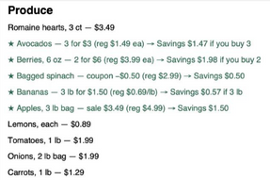 | 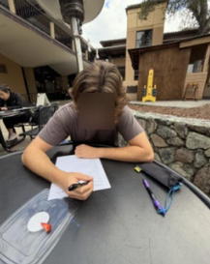 | 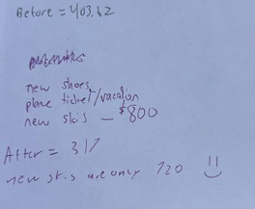
Figure 6: Left: grocery list of items the participant had to shop for. Middle: participant making their list. Right: receipt showing the total savings that the participant accumulated
What worked:  - Participants became significantly more motivated to seek out deals. They re-evaluated purchases with more scrutiny. Saving money felt meaningful with a reward. | What didn’t:  - It's unclear if increased eagerness leads to actual enjoyment. The process was more exciting, but maybe not more fun.
After the prototype was completed, the participant did not report any significant change in their emotional enjoyment regarding the accumulation of savings. Although they exhibited increased motivation and deal-seeking behavior in relation to the savings counter, we cannot definitively conclude that our initial assumption has been validated.

Design Evolution
Our Final Solution
Our final solution, ShopCrawl, arose from the recognition that shopping for everyday necessities often feels more like a chore than an enjoyable experience. We identified that individuals, particularly young adults and urban dwellers, genuinely appreciate the social aspects of shopping, such as browsing stores with friends and discovering new locales together. However, they frequently struggle to find the time to meet new people or coordinate such experiences.
Through insights gained from Experience Prototype 2, we learned that shopping can be not only enjoyable alongside friends but also an exciting way to connect with new individuals in one's locality. ShopCrawl reimagines routine shopping as a social event by facilitating connections among users while they run errands, effectively transforming mundane tasks into opportunities for social interaction and exploration.
Moreover, our solution addresses the challenge of discovering local stores and hidden gems that individuals might not typically encounter. By merging the practical necessity of shopping with integrated social features and place discovery, ShopCrawl cultivates a fun, festive atmosphere that transforms shopping from an obligation into an adventure shared with friends.
Simple Task: Join a Crawl
This task represents a fundamental function of ShopCrawl. Users of the platform can browse and join upcoming crawls in their vicinity, facilitating connections with groups visiting specific stores and locations. Users can discover these crawls through invitations from their existing social networks or by searching local options, applying filters based on preferences such as the number of stores, group size, or types of amenities of interest. Upon their initial login, users can immediately explore public crawls, utilize filters to tailor their shopping experience, and join groups that resonate with their interests. This feature is essential in transforming routine shopping into engaging social experiences while allowing users to discover new local destinations.
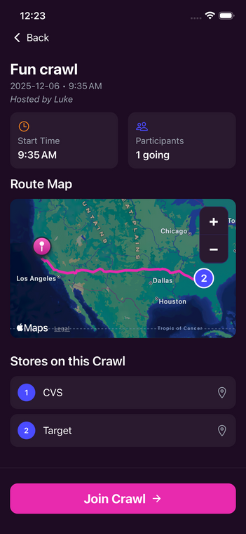 | 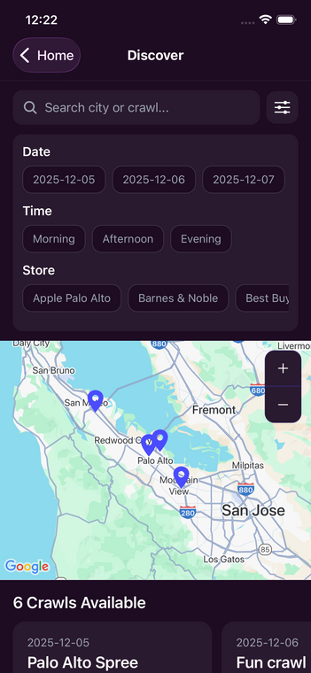 | 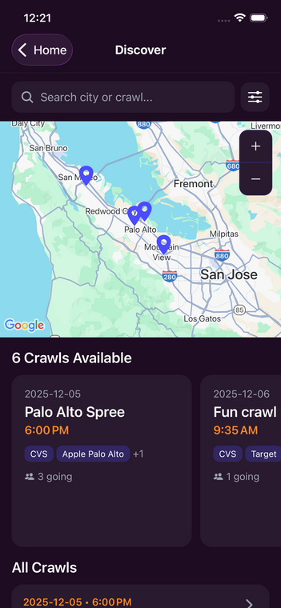
Figure 7: Three key screens users will see while searching for crawls near them.
Moderate: Create a Crawl
This page allows users to establish all essential details for creating a crawl. Users can search for and select specific stores they wish to visit, filter their choices based on preferred times, and designate whether the crawl is public or private. Additionally, they have the option to invite friends or specific groups, as well as set accessibility parameters to ensure inclusivity for individuals with varying mobility or access needs. Each crawl can be personalized with a unique name and customization options. Once created, it integrates into the platform's broader socialization features, enabling participants to view, share, and engage with upcoming crawls.
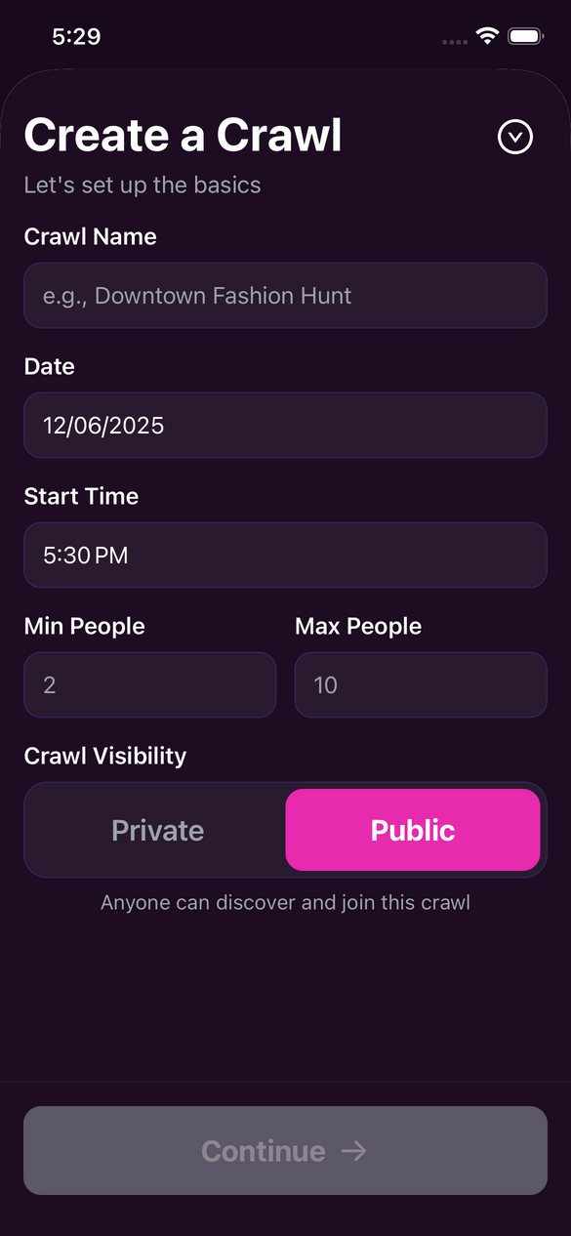 | 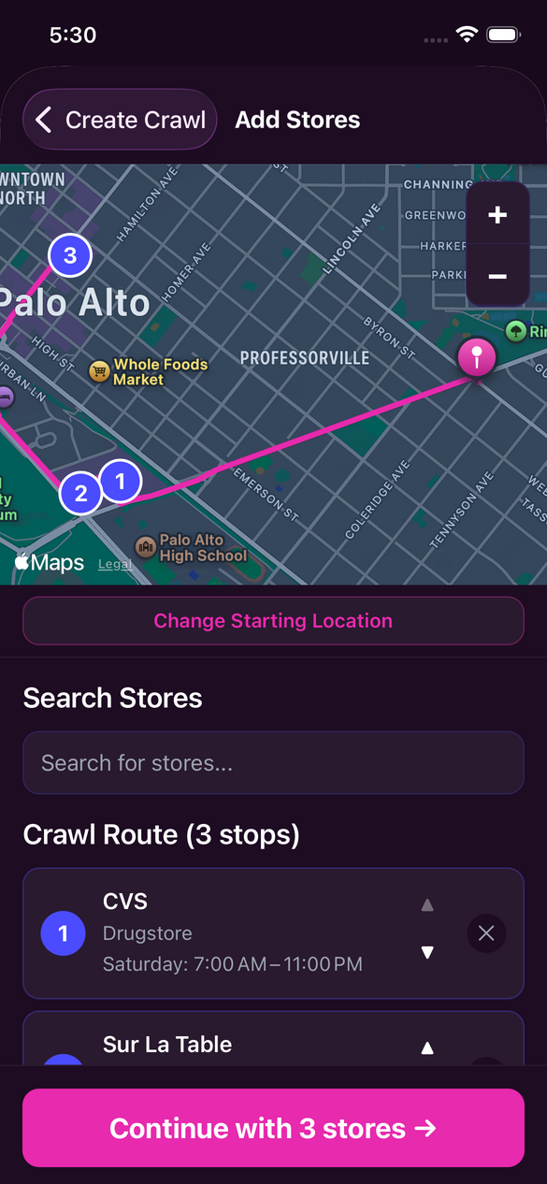 | 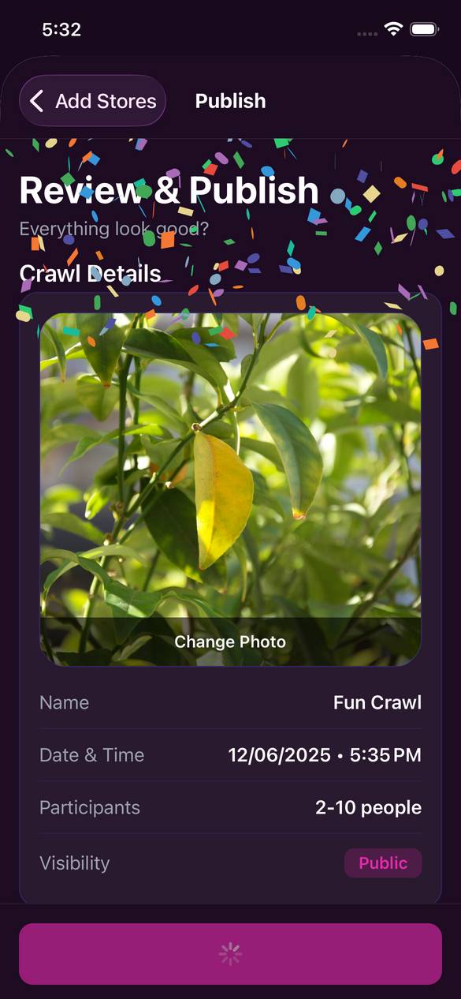
Figure 8: Left: step 1 of the crawl creation process, where users can set the basic details of the crawl. Middle: step 2, where users can decide the crawl's starting location as well as the stores on the crawl. Right: step 3, where the user can add a picture for the crawl, review the basic details, and invite friends to join the crawl.
Complex: Connect with Crawlers
The primary challenge lies in transforming one-off crawls into sustained social connections. For users wishing to maintain contact with individuals they meet during crawls, the platform's socialization features facilitate the addition and management of "crawlers" as friends. Users can revisit past crawls to identify their shopping companions, send friend requests, and integrate these connections into a dedicated friends page.
Once a connection is established, users can directly message crawlers, invite them to upcoming events, and cultivate a lasting social network centered around shared shopping experiences. This approach allows the platform to transcend individual outings, enabling users to sustain relationships, coordinate new crawls, and foster a more engaged shopping community over time.
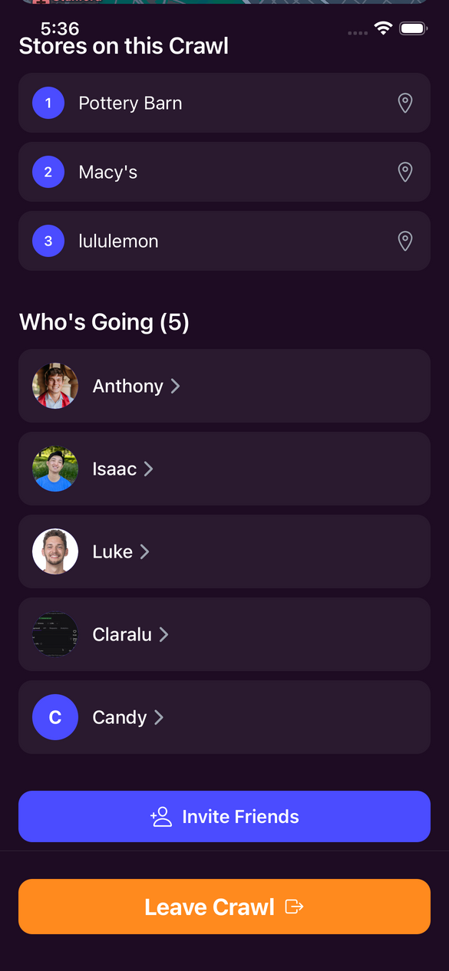 | 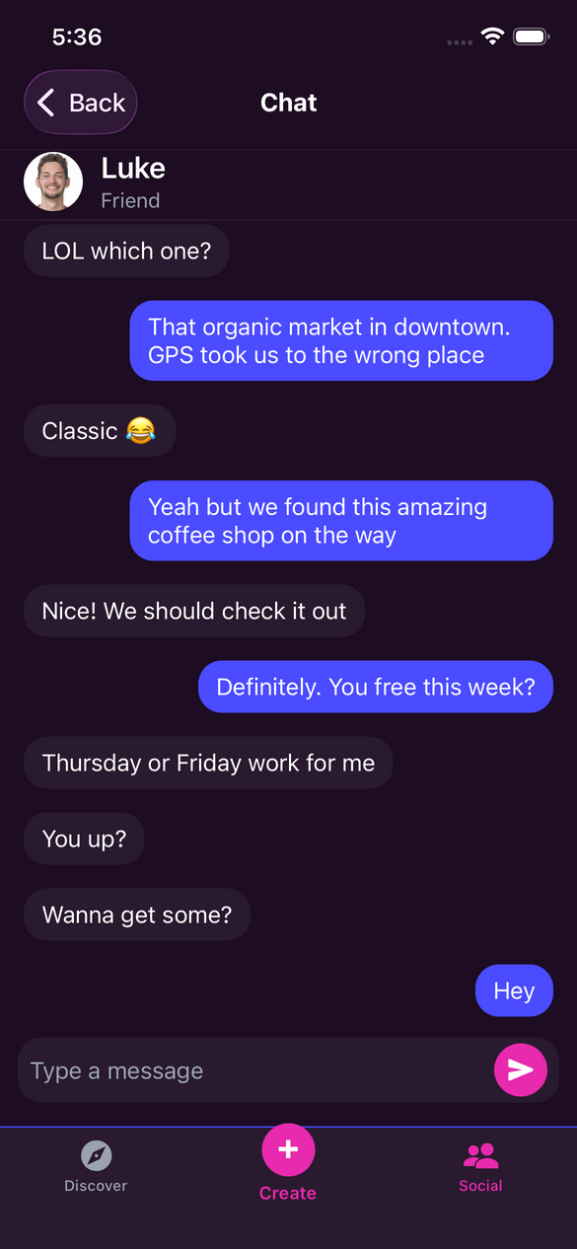 | 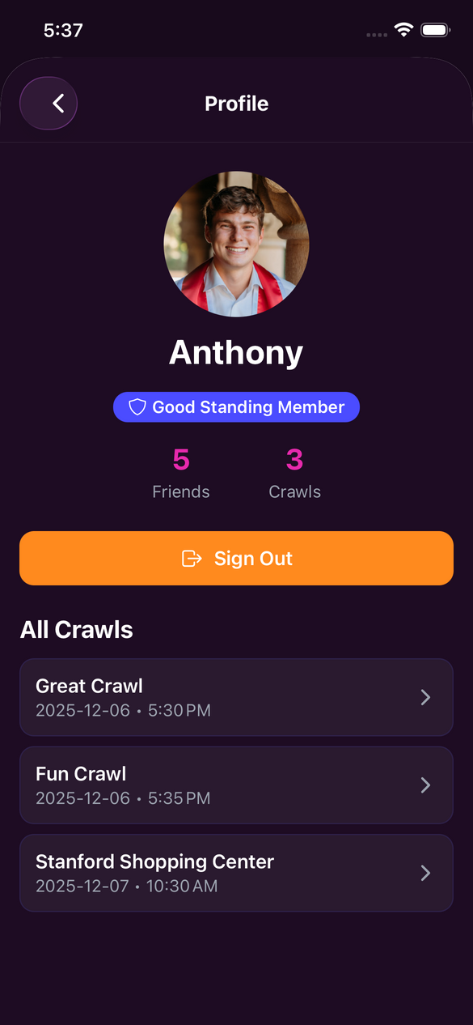
Figure 9: Left: On the crawl details page, users can see which of their friends are on the crawl. Middle: User can use the message feature to send messages to their friends. Right: Users can edit and share their profile page.

Design Evolution Continued
During our brainstorming session on interface design, we generated a diverse array of concepts and potential implementations for ShopCrawl. Initially, we considered an augmented reality (AR) tablet wearable, which inspired imaginative ideas for in-store overlays and innovative experiences during shopping crawls. However, upon evaluating our options, we decided to prioritize a mobile app or tablet-based interface as our primary direction.
A mobile interface is advantageous as it provides users with a comfortable platform for social interactions. The larger screen facilitates the presentation of detailed information regarding crawls, and mobile applications have become increasingly synonymous with shopping experiences. Additionally, this approach can be seamlessly integrated into the existing digital landscape of retail.
Nevertheless, we acknowledge certain trade-offs. In a saturated app ecosystem, distinguishing our product's social features may prove challenging, and there is a risk that it could be perceived as merely another shopping app. Furthermore, the lack of physical integration into the in-store experience may deter veteran shoppers, who might be less inclined to embrace a new app-centric shopping style.
In summary, the mobile interface presents the most compelling balance of usability, familiarity, and feasibility for implementation in our current prototype.
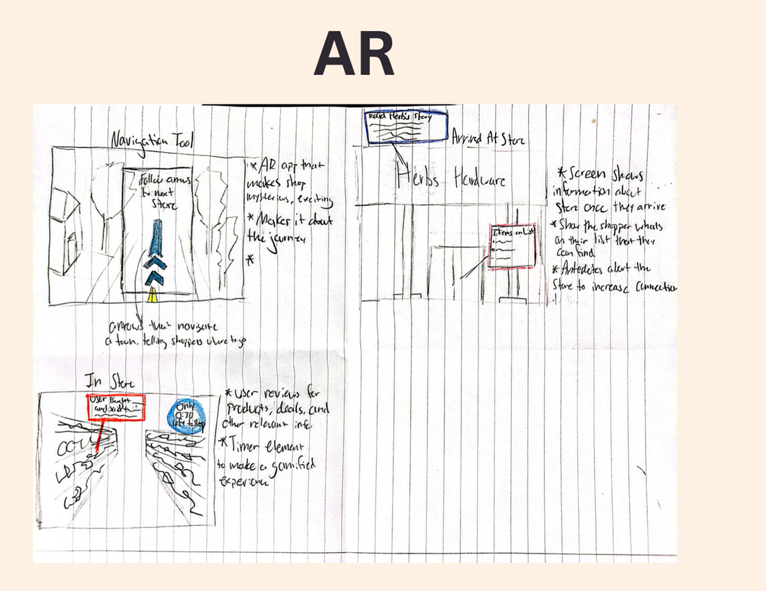 | 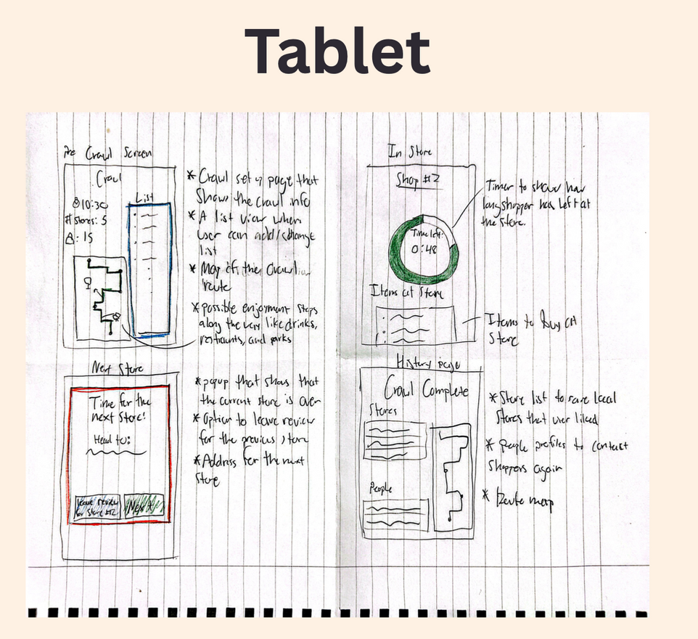 | 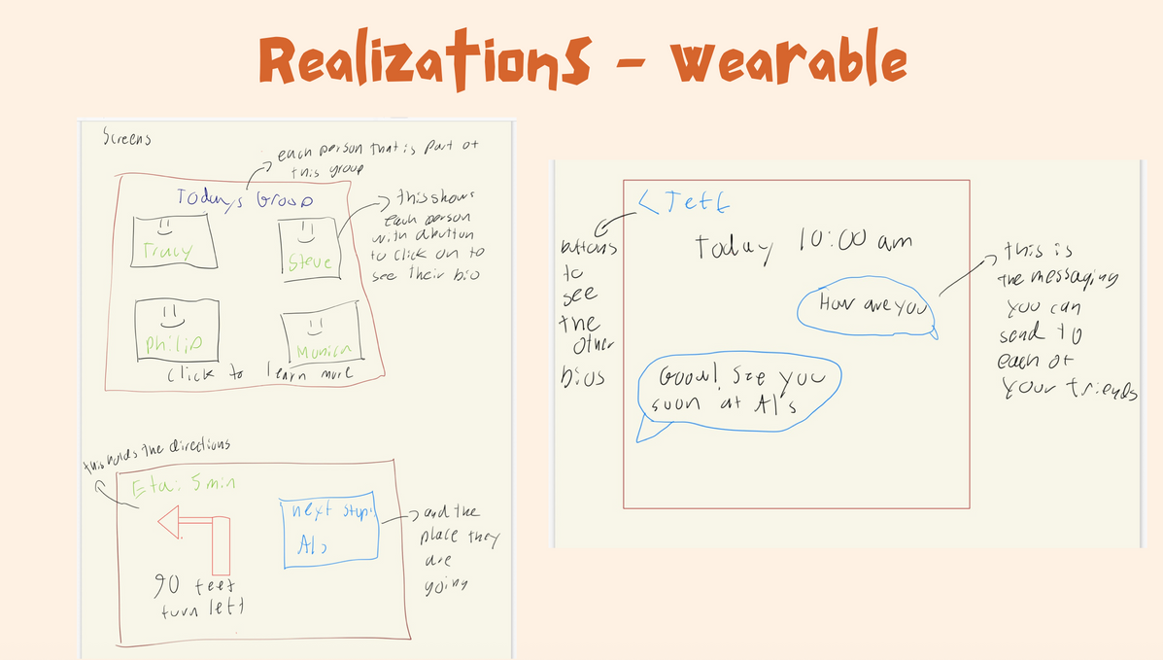
Figure 10: Left: sketches showing ShopCrawl as an AR interface. Middle: Implementation of basic features using a tablet UI. Right: concepts of a wearable device that utilizes location information to facilitate crawls.
Low-fi prototype
To transition swiftly from abstract task flows to tangible concepts that resonate with shoppers, we initially developed a low-fidelity, paper prototype of ShopCrawl. This approach allowed us to maintain a simple, cost-effective design that was easy to modify; if an element proved confusing, we could quickly redraw a screen in seconds rather than making adjustments in a Figma file or altering code. The sketched screens also had the added bonus of allowing users to focus on the flow of the interface rather than design elements like icons and text.
Each screen was sketched on quarter-sized sheets to approximate the dimensions of a smartphone display, and we organized the prototype into three primary tasks: joining an existing crawl (simple), creating a new crawl (moderate), and reconnecting with individuals from a previous crawl (complex). The prototype consistently commenced from a home screen featuring clear entry points for "Join Crawl," "Create Crawl," and "Past Crawls," reflecting the core functionalities that we anticipate users will depend on most.
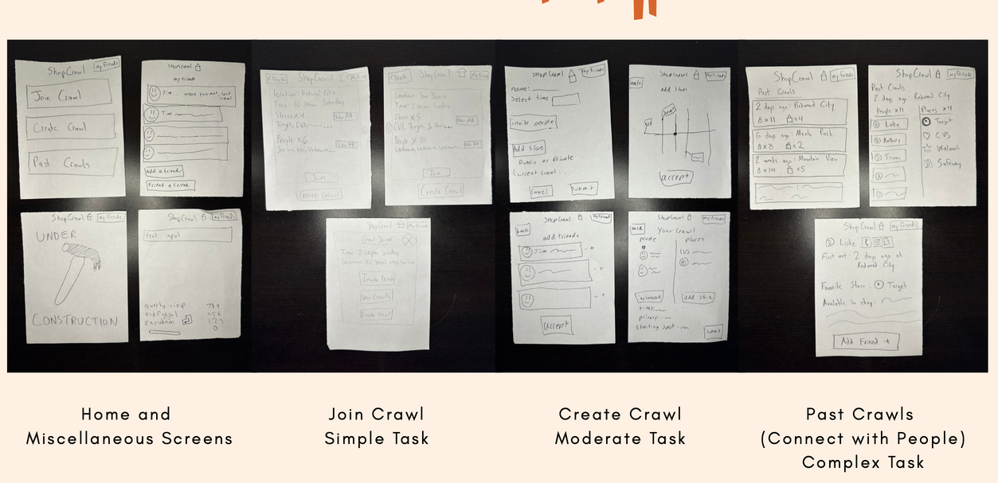
Figure 11: Screens from our low-fi prototype laid out by task
Practically, we ran the prototype like a “paper app”: one teammate acted as the “computer,” swapping sheets as participants tapped, while another took notes and timed how long tasks took. Because everything lived on paper, we could carry the prototype to real shopping locations and test it with actual shoppers right after they finished their trips, aligning with the course’s expectation to iterate quickly and evaluate our designs in context. To assess the quality of our prototype, we employed both qualitative and quantitative metrics to identify opportunities for enhancing the feature set and user flow of the application.
Quantitative data collection focused on measuring the time taken for users to navigate from the home screen to the friend addition feature, as well as self-reported ease of use on a scale of 1 to 5. We recorded task completion times ranging from a minimum of 13 seconds to a maximum of 21 seconds, with one participant unable to complete the task (details discussed below). The average self-reported ease-of-use score was 3.5, which fell short of our target.
For qualitative, we tracked and recorded both positive and negative comments, sounds, and expressions that users displayed while using the prototype. While we received a lot of enthusiastic comments about the premise of ShopCrawl, there was a decent amount of confusion with how the app operated. Particularly with the social features of the app, we realized that our low-fi prototype failed to follow conventional design patterns in regards to the messaging and “friending” process. While we initially wanted to distance ourselves from social media platforms design-wise, the end result was a more convoluted and confusing experience for the user.
One user encountered difficulties in completing the complex task of adding a friend. She expressed her reluctance, stating, “I don’t want to add a friend if I don’t know anything about them.” Additionally, she indicated that the absence of a report button contributed to her distrust regarding the integrity of other users.
This feedback highlighted the significant responsibility associated with developing an in-person social connection app. We recognized that prioritizing safety must become a core design principle moving forward to ensure that users can trust our app as a secure and valuable platform.

Medium Fi
After validating our core tasks with low-fidelity paper sketches, we moved to a medium-fidelity prototype in Figma to refine the flows, visual hierarchy, and interaction details while still iterating quickly. The goal of this stage was not to create a final visual design, but to make the app feel close enough to a real product that users could better understand navigation, screen states, and feedback as they completed our three main tasks: joining a crawl, creating a crawl, and connecting with people from past crawls.
We chose Figma because it allowed us to rapidly build and connect a large number of screens, organize separate flows for each task, and test them all in a single shared prototype. The tool made it easy to adjust layouts, reuse components, and visually trace user paths through the app, which was especially important as our flows became more complex than the earlier paper versions. At the same time, we were aware of its limitations (most notably that interactions are simulated and user input is largely pre-scripted) but we decided the speed and flexibility were worth the trade-off at this stage.

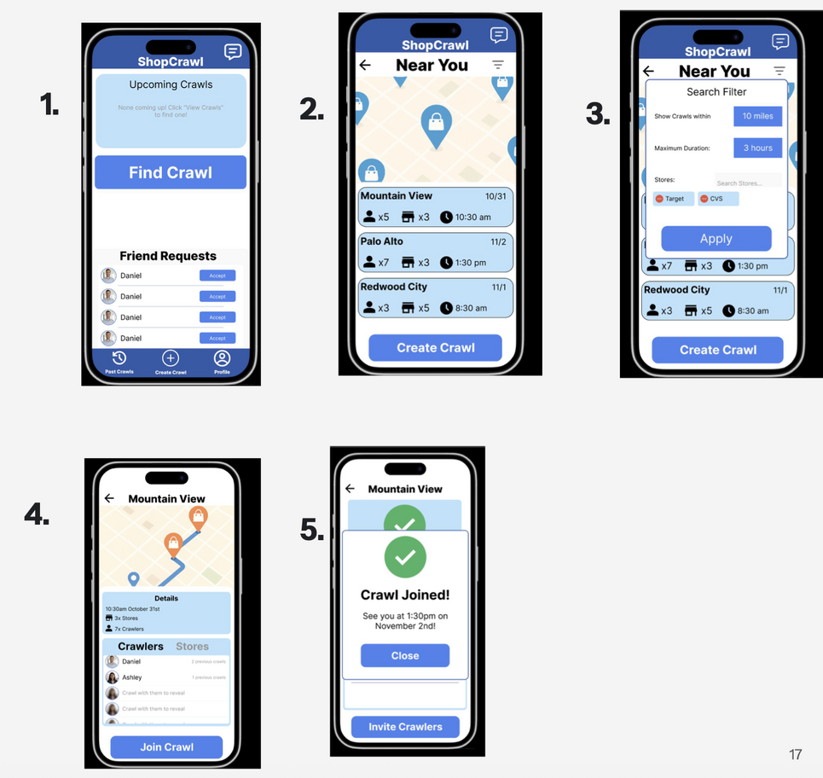
Figure 12: Our simple task flow within our med-fi prototype
As the flows grew more detailed, we also used the medium-fi stage to standardize layout and hierarchy across screens. We aligned back buttons, unified text sizes, and kept key action buttons in consistent locations so users wouldn’t have to relearn patterns from screen to screen. We also added confirmation states (e.g., “Crawl Joined,” “Crawl Created,” “Report Submitted”) to make it obvious when important actions had succeeded. These refinements were aimed at improving both perceived ease of use and actual efficiency by reducing hesitation, misclicks, and repeated actions.
Despite being more realistic, the medium-fi prototype still has intentional limitations. Many elements are hard-coded: profiles, store lists, and example messages are pre-loaded and cannot be edited or truly searched; several buttons simply advance to preset screens instead of processing real data; and some user input (like typing or server responses) is simulated through “Wizard-of-Oz” behaviors such as auto-filled fields and instant success screens. These constraints let us focus on validating the overall flow, clarity of navigation, and perceived safety of the social experience before investing in full interactivity or backend integration.

Heuristic Evaluation
We asked our peers to conduct a heuristic evaluation of our medium-fi prototype using Nielsen’s usability principles, and they surfaced several issues that we hadn’t fully noticed ourselves. The highest-severity problems they identified became the main drivers for our next round of design changes.
Our evaluators identified over 50 significant issues with the app; however, many of these concerns stemmed from limitations in our Figma design rather than the app itself. Consequently, we streamlined the list to 15 meaningful and fundamental changes necessary for enhancing user experience. Among the most critical improvements identified were:
- Enhancing social reporting and transparency within the app.
- Providing users with greater insight into who will be participating in a crawl with them.
- Implementing a mechanism for users to report any misconduct by fellow participants during a crawl.
The following are the 15 heuristic violations, categorized by task, heuristic evaluation problem number, type, and severity.
Simple Tasks / #1 / H1: Visibility of System Status / Severity 4
- Issue: When the user navigates to find another Crawl to join and then returns to the home screen, the previously joined Crawl disappears, giving no indication of persistence or system state.
- The issue pertains specifically to our Figma prototype. In the current high-fidelity version, users can now view their joined, upcoming, and previously participated in crawls.

Moderate Tasks / #3 / H11: Accessible Design / Severity 4
- Issue: Several fields such as “City,” “Length,” and “Upcoming Crawls”, use small fonts and low-contrast light-blue backgrounds, reducing readability and accessibility for many users
- Fix: We undertook a comprehensive overhaul of our front-end design to enhance consistency and incorporate contrasting colors, thereby improving overall readability and user experience.

Moderate Tasks / #5 / H1: Visibility of System Status / Severity 4
- Issue: Users cannot see who has joined the Crawl they created, providing no feedback on group composition or engagement.
- Fix: The functionality has undergone significant changes. Users can now view all individuals participating in a crawl; however, detailed profile information remains concealed until a user has engaged in a crawl with that individual. This approach is designed to enhance privacy while simultaneously fostering transparency among users.

Moderate Tasks / #7 / H5: Error Prevention / Severity 4
- Issue: There is no option to cancel a Crawl once created, preventing users from correcting mistakes or changing plans.
- Fix: Users can now delete a crawl, unjoin a crawl, and edit any crawl they have either created or joined.

Complex Tasks / #11 / H3: User Control & Freedom / Severity 4
- Issue: Users are unable to decline friend requests, removing essential control over their social connections.
- Fix: Users now have the ability to decline friend requests and report individuals, thereby gaining enhanced control over their social interactions within the application.

All Tasks / #12 / H10: Help & Documentation / Severity 4
- Issue: No screens indicate what task the user is currently completing, making navigation and context unclear.
- Fix: We have implemented a navigation bar at the bottom of the screen to enhance user comprehension regarding their current location within the application and the purpose of each screen.

All Tasks / #13 / H11: Accessible Design / Severity 4
- Issue: The app relies heavily on map visuals to communicate store locations, making navigation difficult for users with visual or cognitive impairments.
- Fix: The app now features an interactive map for navigation, alongside a search bar that allows users to manually search for stores and addresses. This enhancement provides users with greater control over their experience by offering both functionalities.

Simple Tasks / #17 / H3: User Control & Freedom / Severity 3
- Issue: The search filter modal lacks controls to adjust distance or time, limiting meaningful filtering.
- Fix: The filter options align more closely with anticipated user preferences. However, further testing and user research are necessary to determine the specific filtering needs that will most effectively enhance the user experience.

Simple Tasks / #19 / H2: Match Between System & the Real World / Severity 3
- Issue: Crawl cards do not show the total length of the Crawl, preventing users from understanding the commitment.
- Fix: You can now view the duration you will spend at each store, as well as the total time allocated for the entire crawl.

Simple Tasks / #21 / H5: Error Prevention / Severity 3
- Issue: On the Crawl details screen, it is unclear which store serves as the starting point, leading to planning confusion.
- Fix: Each store is now assigned a number in the list as well as on the map, visually indicating the sequence in which the stores will be visited

Simple Tasks / #22 / H8: Aesthetic & Minimalist Design / Severity 3
- Issue: The screen appears visually overwhelming, with oversized map pins, heavy blue Crawl cards, and equal visual weight across elements. The “Create Crawl” button blends into the list.
- Fix: incorporated contrasting colors and reduced visual information. The text content has been minimized, placing greater emphasis on visuals to effectively convey the current system status.

Moderate Tasks / #29 / H12: Value Alignment & Inclusion / Severity 3
- Issue: Users cannot remove a participant who makes them feel unsafe, creating a significant safety and inclusion concern.
- Fix: Users have the ability to remove individuals from the crawl if they were the ones who created it.

Moderate Tasks / #36 / H9: Help Users with Errors / Severity 3
- Issue: No feedback is provided when a selected store is closed during the planned Crawl time.
- Fix: Our search algorithm filters stores by whether they're open or closed at that specific time.

Complex Tasks / #37 / H12: Value Alignment & Inclusion / Severity 3
- Issue: The reporting flow lacks empathetic language and does not connect users to safety resources, reducing emotional support.
- Fix: Our reporting system has been enhanced to include more user-friendly language and a dedicated support hotline, allowing users to speak directly with a representative for immediate assistance with any issues. Additionally, we have incorporated increased contextual information to ensure users feel acknowledged, which will also enable us to respond more effectively to reports.

All Tasks / #42 / H3: User Control & Freedom / Severity 3
- Issue: There is no way to set a maximum number of attendees for a Crawl.
- Fix: Users now have the ability to establish both a minimum and a maximum number of crawlers permitted to participate in a crawl. If the minimum number is not met, the crawl will be canceled and subsequently deleted. Conversely, once the maximum number is reached, the crawl will be removed from the search results for other users.

All Tasks / #43 / H4: Consistency & Standards / Severity 3
- Issue: Button sizes, text weights, icon alignments, and blue color tones vary significantly across screens, reducing visual consistency.
- Fix: The issue originated with our Figma design rather than the application itself. This has since been resolved, resulting in greater consistency throughout the app.

As previously noted, many of the heuristic violations stemmed from the limitations of our medium-fidelity prototype. We addressed numerous issues simply by enhancing the fidelity of our application. The identified heuristic violations are listed below.

Moderate Tasks / #6 / H1: Visibility of System Status / Severity 4
- Issue: When starting to create a new Crawl and then backing out, previously created Crawls disappear, failing to reflect completed actions.
Moderate Tasks / #4 / H2: Match Between System & the Real World / Severity 4
- Issue: A Crawl created in Menlo Park displays as located in Redwood City on the home screen, contradicting user expectations and real-world geography.
Complex Tasks / #10 / H3: User Control & Freedom / Severity 4
- Issue: The “Add Friend” button has no functional output, offering no confirmation, error, or system response.
Extra Violations / #14 / H2: Match Between System & the Real World / Severity 4
- Issue: Clicking any friend request from a user named Daniel displays information and a photo from a different Daniel, causing identity confusion.
Simple Tasks / #15 / H1: Visibility of System Status / Severity 3
- Issue: Pressing the “Invite” button on the Invite Crawlers screen provides no feedback that an invitation was sent.
Simple Tasks / #18 / H2: Match Between System & the Real World / Severity 3
- Issue: The map on the “Near You” screen is a generic placeholder rather than a real mapped location.
Moderate Tasks / #27 / H1: Visibility of System Status / Severity 3
- Issue: The “Add Crawlers” screen cuts off bottom content and does not support scrolling, hiding recommended users and part of the “Add Crawlers” button.
Moderate Tasks / #30 / H2: Match Between System & the Real World / Severity 3
- Issue: The map for “Cool Crawl 7” is a placeholder instead of a real geographic representation.
Complex Tasks / #38 / H2: Match Between System & the Real World / Severity 3
- Issue: Clicking Ashley’s profile from a past Crawl opens Daniel’s profile instead, undermining trust in user identity.
Complex Tasks / #40 / H7: Flexibility & Efficiency of Use / Severity 3
- Issue: The Messages screen does not make it clear how to send a message, causing task failure for many users.
Simple Tasks / #79 / H1: Visibility of System Status / Severity 3
- Issue: After joining a Crawl, there are no next steps or status updates to indicate how or when the Crawl will occur.

The identified heresies highlighted significant deficiencies in our app's design, particularly regarding features and transparency. The application's aesthetic felt uninspiring and static, which contradicted our vision of creating an engaging and adventurous user experience. To address this, we transitioned from a color palette dominated by blues and whites to one featuring deep purples and vibrant accents, evoking a sleek, nightclub-like ambiance.

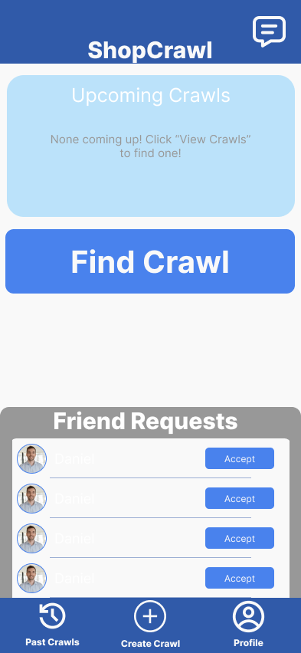 | 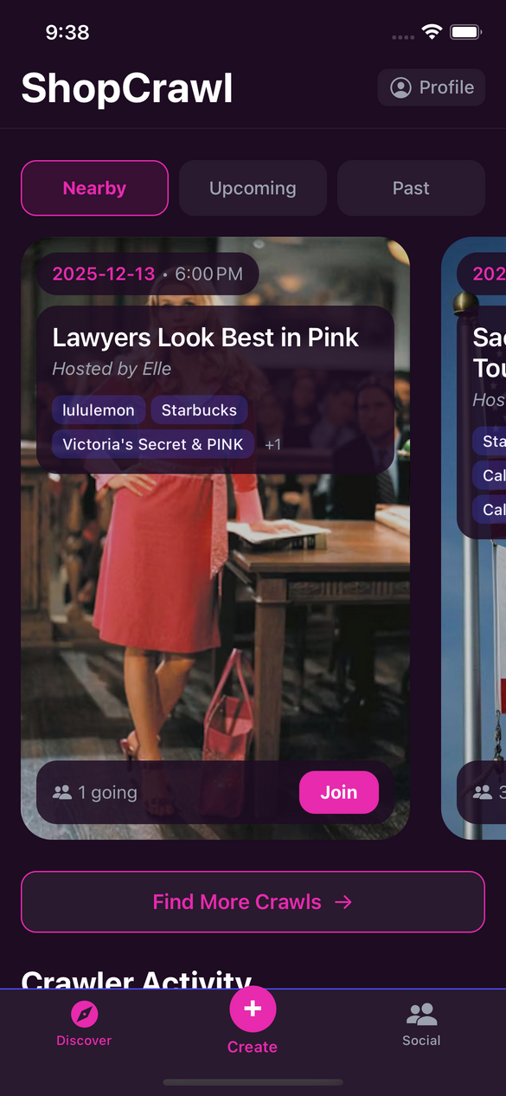
Figure 13: Left: the home screen of our medium fidelity prototype. Right: the home screen of our high-fidelity prototype

Furthermore, we recognized the need to enhance the social aspects of the app, prioritizing transparency and trustworthiness. To achieve this, we empowered users with greater control over their social interactions by enabling them to view user profiles and report inappropriate behavior. We also introduced functionality that allows users to accept or decline friend requests, thereby fostering more meaningful connections. Additionally, improvements in messaging transparency and the introduction of a community ranking system ensure that users can advance by contributing positively, or decline based on negative behaviors and reports. These enhancements have been successfully integrated into our high-fidelity prototype.

Values in Design
Throughout the creation of ShopCrawl, we established a set of core values that guided every stage of our design process. These values helped us shape not only the features we prioritized, but also how we envisioned people interacting both with the app and with each other during real-world Crawls. The values we centered were sociability, safety, accessibility, and efficiency.
Identified Values
Sociability
ShopCrawl exists to make social shopping easier, more fun, and more inviting. Because many people find chore shopping boring or isolating, one of our primary goals was to transform these everyday errands into opportunities for connection. Our needfinding and usability tests confirmed that users were excited by the idea of shopping as a group activity, especially when it created opportunities to meet new people. To support this, ShopCrawl emphasizes interactions that facilitate planning, joining, and reconnecting with others who share the same shopping experience.
Safety and Trust
Early user testing made it clear that users would not feel comfortable connecting with strangers without mechanisms to ensure trust. One participant refused to add a new friend because they “didn’t know anything about them,” highlighting that social features must be paired with strong safety considerations. Because ShopCrawl encourages meeting people both digitally and in person, safety became a central value, shaping decisions around reporting, reputation, and profile clarity.
Accessibility
We wanted ShopCrawl to be usable by as broad a community as possible. This included visual accessibility, mobility needs, and cognitive accessibility. Since Crawls contain details about large or unfamiliar shopping areas, the interface needed to be readable, supportive, and predictable. Accessibility ensured that ShopCrawl did not exclude users who might otherwise have difficulty navigating a map-heavy or socially interactive app.
Efficiency and Ease of Use
Because ShopCrawl is designed for real-world use—often while users are walking between stores or checking the next destination—efficiency was a critical value. Our usability goals reflected this: we measured how quickly users could complete tasks and monitored whether the interface supported fast, low-friction interactions. Efficiency was not only a usability requirement but a value that shaped which features mattered most.
How These Values Are Embedded in Design Features
Sociability in Design
We embedded sociability by making it easy for users to join, create, and connect through Crawls. A dedicated “Social” tab with Past Crawl summaries, friends lists, and messaging functionality helps users build connections that start during shopping and continue afterwards. The app’s tone, layout, and dark “party mode” aesthetic reinforce the idea that ShopCrawl is a fun, communal experience rather than a typical shopping tool.
Safety and Trust in Design
Our prototype incorporates reporting, user community standing, and friend request workflows to help users feel secure when connecting with new people. Profiles include bios so users can make informed decisions about who they add. Although some elements, like customer service review of reports, are Wizard of Oz implementations, their presence communicates the priority we place on safety.
Accessibility in Design
Accessibility informed multiple interface decisions:
- Mobility-friendly filtering, allowing Crawlers with mobility constraints to find accessible routes.
- High-contrast dark mode to support low-vision users.
- Large, generous tap targets exceeding accessibility minimums.
- Clear visual hierarchy to reduce cognitive load.
- Consistent patterns and no hidden gestures, ensuring discoverability for all users.
The combination of these elements makes ShopCrawl suitable for a wide range of abilities and contexts.
Efficiency in Design
Efficiency appears in fast flows, transparent navigation, and clear page structures. User testing revealed confusion around inconsistent buttons, which led us to streamline navigation with a persistent navigation tab bar at the bottom. The optimized routing system, powered by Google Places and custom logic, further supports efficiency by reducing planning time.
Value Tensions
Sociability vs. Safety
A central tension emerged between building an open, vibrant social experience and giving users enough information and protection to feel safe. While ShopCrawl encourages connecting with new people, early testers expressed hesitation about befriending strangers without context. We addressed this by adding profile details, reporting features, and a reputation system. Because our prototype still uses Wizard of Oz moderation, we were unable to fully resolve every safety issue, but design decisions aim to prioritize user comfort without diminishing sociability.
Meeting New People vs. Protecting Boundaries
ShopCrawl’s purpose is to help people meet others during real-world shopping. At the same time, some users prefer controlled, private interactions. While we allow both public and private Crawls, and require friend acceptance for more personal interactions, some tensions remain—particularly around how much visibility users should have into non-friends on a Crawl. We addressed part of this by limiting certain features like Crawl invitations until individuals have connected, but a complete solution will require richer privacy controls in future iterations.
Accessibility vs. Information Density
Many features such as route data, store information, and social tools compete for screen space. Packing too much information risks overwhelming users, but removing information may make Crawls harder to navigate. We prioritized clean layouts, large buttons, and high-contrast visuals, but certain trade-offs remain, especially for visually impaired users who rely heavily on maps. Fully addressing this tension would require non-visual route guidance, which was beyond the scope of our prototype.
Efficiency vs. Rich Social Features
Some features that increase sociability like detailed profiles, messaging threads, or Past Crawl histories also increase complexity and time-on-task. Our solution was to let users access richer details only when needed, rather than exposing everything in high-traffic screens.

Final Prototype Implementation
We built our high-fidelity ShopCrawl prototype as a functional mobile application that runs through Expo Go on mobile devices. Our goal was to create a polished, socially driven shopping experience that feels lively and interactive. This section outlines the tools, techniques, and design decisions that shaped our final prototype.
Tools Used
We started with Figma Make to quickly test out new color palettes. We wanted to make it immediately obvious that the Crawl should be a fun “party vibe” while balancing it with accessibility and clarity. To accomplish this we focused on a dark, purple tone based palette, and asked Figma Make to prototype some example home screens.
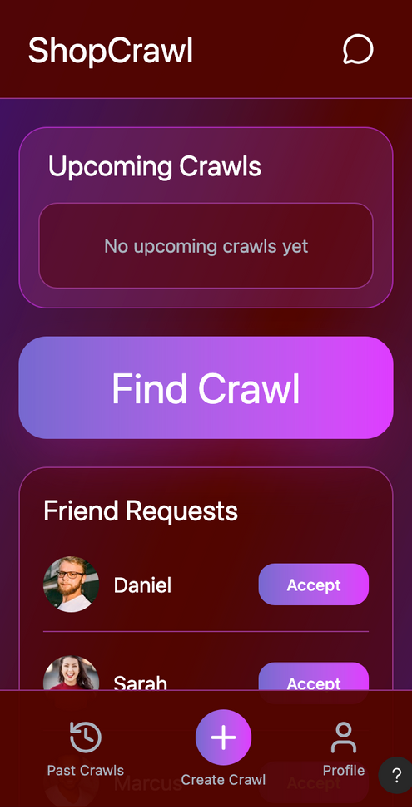 | 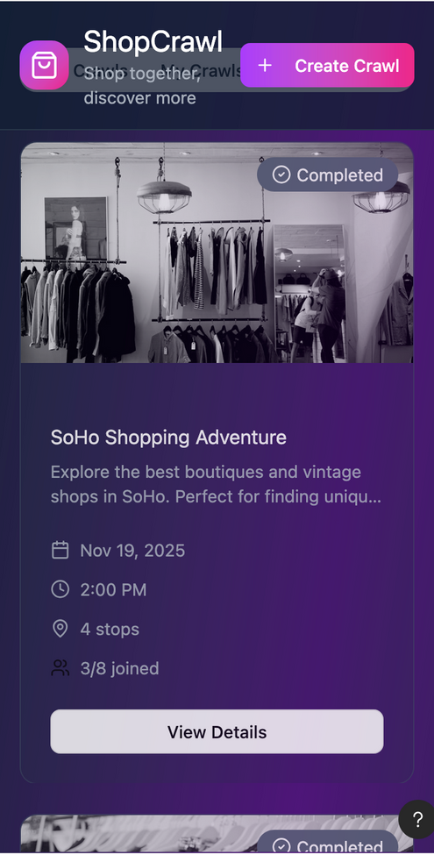
Figure 14: Left: example of a bad color palette from Figma Make. Right: A better example of a color palette from Figma Make.

React Native through Expo served as the core development framework. Expo allowed us to test the mobile app instantly on real devices. This made it extremely easy for our team to share builds, troubleshoot issues, and refine interactions together.
Google Places API powered our location search and routing features. It allowed users to look up real stores near their chosen starting point and provided the location data needed to build each Crawl’s route. The API also enabled us to generate an optimal route between destinations, making the Crawl-building experience feel grounded and realistic. While adding custom routing with Places added some technical complexity within Expo, it significantly enhanced the functionality and usefulness of our prototype.
For our backend, we used Supabase to store Crawl details, locations, attending Crawlers, profile information, sent messages, and sent friend requests. Supabase gave us a lightweight but reliable database that was easy to populate and query during tests. Supabase allowed us to implement real data flow for core tasks such as joining, creating, and connecting on Crawls, as well as real implementation of social features like messaging and adding friends.
Finally, GitHub managed our version control and collaboration. While this added some coordination overhead, it ensured that frontend, backend, and design updates remained consistent across team members.
Together, these tools allowed us to create a functional, visually cohesive, and technically ambitious prototype within our development timeline.
Wizard of Oz Techniques Used
Because ShopCrawl aims to simulate a full social environment with Crawls, messaging, invites, profiles, and safety features, we used several Wizard of Oz techniques to make the prototype feel realistic without requiring a full production-level backend or customer support.
Fake authentication: During login, users may enter any password to pass verification. We intentionally bypass password storage to simplify testing and avoid unnecessary friction. While this reduces security, it keeps onboarding smooth for prototype users.
Simulated customer service: Reports submitted through the “Report User” interface are not reviewed by real moderators. Instead, the interface simply demonstrates how our safety flow would work in a full version of the app.
Simulated Crawler activity: The “Crawler Activity” feed on the home page is fully hard-coded to give the sense of a bustling community.
These Wizard of Oz techniques helped us maintain the feeling of a vibrant, safe social environment while focusing our development time on core shopping, routing, and discovery features.
Hard-Coded Techniques Used
To support realistic testing across key tasks, several elements of ShopCrawl were hard-coded into the app:
Completed Crawls are stored manually so testers can experience reconnecting with Crawlers from past events.
The Crawler Activity feed shows fixed posts representing what a real community feed might look like.
Review and rating UI exists, but reviews are not stored or displayed to others.
Authentication restricts creation of duplicate profile names, but passwords are not saved or validated.
Hard-coding these components allowed us to focus on the core functionality that matters most: creating Crawls, customizing routes, joining events, and discovering groups nearby.
AI Tools Used
We used Figma Make to generate a variety of color palettes and test different visual styles quickly. Because our heuristic evaluation emphasized the importance of consistent, accessible design, having an AI tool explore numerous palette possibilities allowed us to converge on a visual language that was both vibrant and readable.
Cursor helped set up the backend routing and Google Maps API logic. This involved real server endpoints, store prioritization based on proximity, and communication between the app and routing server. Cursor accelerated this process by handling boilerplate code and offering suggestions for architecture. This let us implement route building—a key user experience feature—much faster than if we had created every endpoint by hand.
In both cases, AI tools acted as accelerators, helping us explore design and engineering possibilities more efficiently while letting us focus on user experience, accessibility, and interaction flow.

Reflection & Next Steps
Key Learnings About the Design Thinking Process
Across the quarter, our team gained a deep appreciation for the iterative, user-centered nature of the design thinking process. One of our most important learnings was the value of going into needfinding without assumptions. Early on, we believed chore shopping was simply inconvenient or boring, but our interviews revealed deeper emotional dynamics: people often feel isolated when running errands alone, they hesitate to meet new people in unstructured contexts, and they see personal time as scarce and precious. These insights pushed us to reframe our problem from “make shopping easier” to “make shopping socially meaningful.”
Prototyping, testing, and revising constantly were also essential to shaping our final direction. Our low-fi experience prototypes surfaced unexpected issues ,such as participants refusing to add strangers without more information, which fundamentally reshaped our approach to safety, user profiles, and trust-building features. Later, our heuristic evaluations revealed dozens of clarity, consistency, and control issues, many of which drove major revisions to navigation, layout, and social flows. By the time we reached our hi-fi prototype, our design had evolved through user feedback, peer critique, and repeated redesigns, resulting in a more intuitive and engaging product.
Finally, we learned the importance of a communicative team. Our ability to openly share progress, divide tasks, and support one another streamlined the entire process. When one area became challenging, another team member could step in to help. This collaborative environment made ShopCrawl not just possible, but deeply enjoyable to create.
Key Learnings About Our Studio Theme: Adulting Made Easier
Working within the Adulting Made Easier theme helped us think critically about the emotional and logistical barriers adults face during everyday responsibilities. Chore shopping seems simple on the surface, but our research showed how strongly it interacts with loneliness, time scarcity, and the difficulty of forming new social connections after college.
We learned that adults often want meaningful social interaction, but don’t always have the energy to initiate it. This insight shaped a core pillar of ShopCrawl: lowering the activation energy required to connect with others. Turning errands into shared activities makes socializing easier to integrate into everyday life.
The studio theme also pushed us to consider practicality and trust: two values that repeatedly surfaced in our research. Shopping with strangers or acquaintances raised legitimate safety concerns, which led us to incorporate reputation systems, friend visibility, and reporting features into our design. Our theme encouraged us to build a tool that supports adult responsibility (staying safe, using time well) while making these responsibilities less burdensome and more joyful.
Finally, we learned not to treat social discovery and community-building as afterthoughts. Making adult life easier sometimes requires building systems that encourage collaboration, shared experiences, and emotional connection. ShopCrawl ultimately reflects this philosophy by blending utility with fun, and responsibility with play.
Key Learnings About ShopCrawl
Designing ShopCrawl taught us to remain flexible and open to where users pull the project. Our early ideas explored everything from wearables to AR interfaces, but testing quickly showed that users wanted something simple, familiar, and integrated into their existing shopping behaviors. The mobile-first direction emerged naturally from these insights.
We also learned how critical trust and safety are in any app that facilitates meeting new people. One of our testers explicitly refused to add a stranger without more context, which became a turning point that led to our user rating system, reporting flows, and profile improvements. These features ultimately strengthened the app’s potential to support meaningful, comfortable interactions.
Another key insight was recognizing how important efficiency and clarity are for chore-related tasks. Adults want things to just work. Many inefficiencies in earlier prototypes—confusing navigation, ambiguous controls, inconsistencies between screens—created friction that undermined the fun, social side of our app. Addressing these issues helped us better align the product with our value of making adult life easier, not more complicated.
Next Steps
If we had more time, we would focus on expanding ShopCrawl’s functionality and improving its technical maturity in several key areas.
Our top priority would be fully developing a safety ecosystem including verification of new users, automated moderation, and true user ratings that influence profile visibility. This would support genuine social connection while preserving user trust.
We would also expand the Crawl discovery experience, integrating real-time recommendations, personalized suggestions based on past Crawls, and more refined filtering such as budget constraints or store categories.
An idea we are open to exploring is to enable non-community created, sponsored Crawls directly created by stores that have exclusive benefits such as a Crawl specific discount. This would act as another incentive for people to get out there and join Crawls.
Ultimately, ShopCrawl has been a meaningful exploration of how everyday responsibilities can be reframed into opportunities for connection, joy, and community. We are proud of the insights, design decisions, and user-centered learnings that shaped ShopCrawl, and we hope those ideas continue to inspire future approaches to making adult life feel a little more social and a little less monotonous.

